Section 03 - Lessons 21 | campaign planning

ronny abraham

Table of Contents
1. Links
2. Notes
2.1. numbers & budgets
2.1.1. cpa and basic budget
2.1.2. top of funnel
2.1.2.1. allocate TOF budget
2.1.3. nothing is set in stone
2.1.3.1. three ways people can consume the same content
2.1.3.2. bottom line
2.1.3.3. important suggestion: videos
2.1.4. after creating a TOF campaign
2.1.4.1. how to break down the 10 ad sets
2.1.4.1.1. Lookalike Audience: 6 out of 10
2.1.4.1.2. Cold Audience: 3 out of 10
2.1.4.1.3. Faisafe audience: 1 out of 10
2.1.4.2. TOF Campaign Audience testing
2.1.5. favorite lookalike audiences
2.1.5.1. best audiences types
2.1.5.2. lookalike audiences
2.1.6. favorite TOF ad
2.1.6.1. HOOK AND INSPIRE
2.1.6.2. how to
2.1.6.3. custom audience
2.1.6.4. pro tip
2.1.7. perfect post
2.2. TOF Content
2.2.1. text
2.2.2. videos
2.2.3. lists
2.2.4. contests / giveaways
2.2.5. lead magnets
2.3. Middle of Funnel (MOF)
2.3.1. event goal campaign
2.3.2. start a retargeting campaign
2.4. buyer retargeting
2.4.1. testimonials + user generated content
2.4.2. reach campaign for past buysers
2.4.3. strategies
2.4.3.1. purchase event in 7 days
2.4.3.1.1. process
2.4.3.1.2. why does this work
2.4.3.2. purchase event 30 and 60 days
2.4.3.2.1. 30 days
2.4.3.2.2. 60 days
2.5. optimize for conversions
2.5.1. purpose
2.5.2. Bottom Of Funnel Audience
2.5.3. vip audiences
2.5.3.1. lookalike
2.6. Facebook Pixel
2.7. order of optimization
2.8. dynamic creative
2.8.1. process
2.8.2. analysis
2.9. Ad Creative
2.9.1. general
2.9.2. middle of funnel
2.9.2.1. answer OBJECTIONS that the customer may have about your product
2.9.2.2. test scarcity and FOMO creatives
2.9.2.3. test various ad copy to see which Objection Debunk results in sales
2.9.2.4. high priced product (100$ +)
2.9.3. bottom of funnel
2.9.3.1. user generated content
2.9.3.2. build credibility
2.9.3.3. ads relevant to retarget audience
2.9.3.4. PRO TIP
2.10. User Generated Content
2.11. Track Testing
2.11.1. spreadsheet layout
2.11.1.1. tabs
2.11.1.2. columns

Links
- TOC - Facebook Marketing Notes
- S03:L21 - video

Notes

numbers & budgets
- find business numbers and develop budget
  - customer average order value AOV
  - customer average lifetime value

cpa and basic budget
- CPA = Ad Spend / Number of Conversions
- Break Even CPA = AOV - Expenses = Profit Per OrdeR
- daily budget = 10 x CPA (cost per action)
  - optimal budget for collecting data in facebook ads

top of funnel
- 20% of daily ad spend budget
- feed facebook pixel
- identify interested users
- future warm audience
  - retarget
  - look alike audience

allocate TOF budget
- find Ad Set target market
  - optimize later
  - split test one variable per
- break TOF budger
  - traffic
  - video views
  - post engagement

nothing is set in stone

three ways people can consume the same content
- you can put $100 to a traffic campaign with a great blog post you want to drive users to
- you could include the blog post URL in a facebook and Post Engagement campaign
- create a video version of the blog for Video Views

bottom line
- split test
  - content
  - ads
- try things out

important suggestion: videos
- create 1-2 videos for Video Engagement Custom Audiences
- Facebook FAVORS video content

after creating a TOF campaign
- toggle Advantage Campaign Budget option at Campaign Objective selection level
- allocate at $1 minimum per Ad Set
  - this is just the minimum
  - it will end up higher
- test 10 Ad Sets
- rewatch lecture The Compelte Facebook Spit Testing Guide
  - duplicate ad sets
  - duplicate split test

how to break down the 10 ad sets

Lookalike Audience: 6 out of 10
- select Lookalike Audiences of people who have taken action
  - leads
  - purchases
  - etc

Cold Audience: 3 out of 10
- starting from scratch it will be 9 out of 10
  - no custom audiences
  - no lookalike audiences
- target a COLD AUDIENCE in each ad set a single
  - interest
  - demographic
  - gender
  - age
  - location
  - behavior
- go BROAD to find INTERESTED people
  - pick a large range
  - age
  - device (ios, etc.)
- create an Avatar of the perfect customer

Faisafe audience: 1 out of 10
- MAX Broad audience
- target
  - one country
  - large age group 18-65
  - all genders
- fail safe ad set in case the prev 9 sets are wrong
- the relevant ad content will get who you need to get

TOF Campaign Audience testing
- every 3 days / 1000 impressions per ad set
- review ad sets and toggle off losers
- TOF is for testing
  - replace the loser with a new set
  - change some variable
  - duplicate winning ad sets and adjest it
- large budget
  - 50 ad sets targeting 1 audience each
- small budget 100-500 per day
  - 10 ad sets
  - toggle off losers every 3 days and add new test audience

favorite lookalike audiences
- warm is always best
  - someone who engaged
- someone who looks and acts online same as your warm audience

best audiences types
- Website Custom Audience : visitors by time spent - top 25%
  - removes users who bounce
- Facebook Page Custom Audience
  - everyone who engaged with your page
- instagram business profile custom audience
  - everyone who engages with your business
- Video Engagement Custom Audience
  - people who either completed or viewed at least 15 seconds of your video (ThruPlay)
- Website Custom Audience : AddToCart
  - create a 7, 14, and 30 day custom audience
- Website Custom Audience : InitiateCheckout
- Website Custom Audience : All website visitors
- Website Custom Audience : People who visited specific web pages
  - e.g. landingpage
- Website Custom Audience: Buyers
  - mutliple
  - single
  - all
- Customer List Audience : setment lists
  - email subscribers
  - buyers

lookalike audiences
- replace all COLD TRAFFIC with LOOKALIKE AUIDENCES
- you need 1000 users or more
- lookalike perform best for TOF targeting

favorite TOF ad
- Post Engagement Campaign
- normally people use a lead capture page via Conversion that costs $1-$5 per lead

HOOK AND INSPIRE
- publish a post to a facebook page asking a question
- engages and comments on post
- a comment is equivalent to a micro transaction with your brand
  - warmer

how to
- target Broad Audience
- Post Engagement Campaign
  - also builds up social proof
  - natural virality
  - if its large enough facebook will lower costs
- GET COMMENTS ON THE POST - ie answers to the question

custom audience
- Facebook Page Custom Audience > People who engaged with any post or ad

pro tip
- try to get a few likes on every post
- it looks good

perfect post
- 1+ share per 100 impressions
- comments under .25$ each
- use the post ID for a new ad

TOF Content
- people hate being sold
- don’t sell unless the product is under $30 (impulse buy)
- give away value and retarget
- try at least 2 different TOF ad content optinos
  - each offering a different value proposition

text
- polls
  - this is good for finding out more about your clients
- surveys
- quizzes
- quetions
- questions that prompt for user comments
- CTA send message button

videos
- commericals
- educational meets entertaining

lists
- top 10 ways to XYZ
- The 7 Best Products for XYZ (free value relevant to your target market)

contests / giveaways
- can attract parasites
- win/win giveaways
- ie ’free pie with every order’

lead magnets
- free course
- ebook
- tutorial
- coupon
- food
- product
- etc

Middle of Funnel (MOF)
- 50% of daily ad spend budget is allocated to MOF campaigns
- retargeting WARM AUDIENCES
- testing targeting cold audiences with offer or “sale ad”

event goal campaign
- Conversion Objective > Purchase
- could be selling or collecting leads
- have facebook find and optimize ads for users most likely to CONVERT
- build Custom Audiences with most likely to convert

start a retargeting campaign
- you can start a retargeting campaign with as little as ONE person in the custom audience
- best to have 1000 in custom audience before retargeting

buyer retargeting
- facebook campaigns work better at retargeting than emailing

testimonials + user generated content
- photos / videos of customers using the product
- create a contest to get past customers to create content for you

reach campaign for past buysers
- set conversion to Awareness (REACH)
- use that instead of SALES

strategies

purchase event in 7 days

process
- create a custom audience of users who have made a PURCHASE event in the past 7 days
- retardget this audience with an Awareness (REACH) objective campaign
- at the AD SET level, set the Frequence Cap to 1 impression every 3 days
- Create an ad with a selfie video (best engagement results by far for us)
  - say something like: Thank you so much for your purchase from [company name]! We are so excited to have you as part of our community! If you need anything, please feel free to reach out to us! Thanks again!

why does this work
- extremely effective
- people appreciate being appreciated!

purchase event 30 and 60 days
create two Custom Audiences of users who made a PURCHASE event in the past 30 and 60 days.

30 days
- Let customers use your product/ service for 30 days before asking for a review via email
- this eliminates the users that are unhappy or already claimed a refund in the first 30 days

60 days
- gamify (ie contest) the creation of user generated content
  - e.g. tesimonial / review
    - videos
    - photos
- create an ad targeting “Purchase in past 60 days” Custom Audience and exclude “Purchase in past 30 days” Audience
  - we are targeting buyers between 31-60 days

optimize for conversions
- facebook is seeking users that are most likely to CONVERT (view content, signup, buy, etc)
  - target that user as much as possible
- SALES conversion campaigns are the most expensive / high CPM user to market
  - split test other campaigns
    - Video
    - Traffic
    - etc
sales conversion type | goal
TOF | View Content
MOF | Add to Cart
BOF | Purchase

purpose
- optimize and build custom audiences likely to CONVERT
- other reasons:
  - lower costs
  - want a specific action taken e.g. Engagement -> Video Views

Bottom Of Funnel Audience
- Video Views 75%
- Customer Lists (email leads)
- add to cart
- Initiate Checkout
- MOF View Content (from MOF Custom Audiences, such as XYZ product page view)
- Webiste Visitors by time spent (top 25%)
- Facebook Page Custom Audience > People who engage with any post or ad

vip audiences
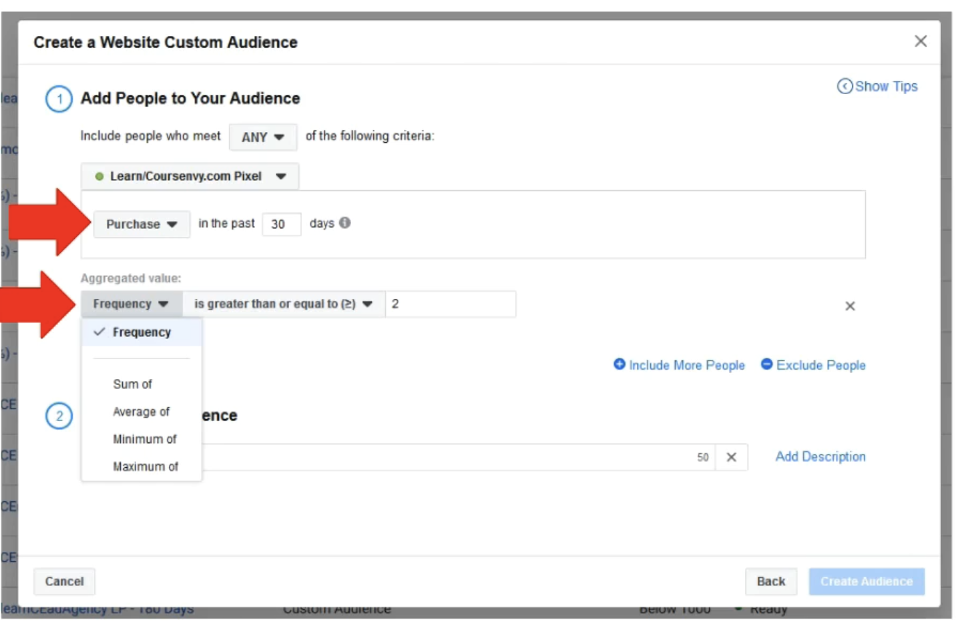
- more than one purchase
- spent over a certain amount

lookalike
- wait till it’s over 1,000+ in size
- create lookalike

Facebook Pixel
- install Facebook Pixel on website and let it collect event data
  - collect 100 total conversion events before starting sales campain for that specific conversion event

order of optimization
- identify target audience
  - interested people
  - action takers (buyers)
- use testing to determinate what creative works best for target market
  - examples
    - images
    - videos
    - ad formats (ie carousels)
- test and tweak copywriting

dynamic creative
- always test 5 ad creative variables.
  - images
  - videos
  - primary text
  - headline
  - etc
- never assume you have the perfect ad
- bulk test variables with Dynamic Creative enabled ad AD SET level

process
- create single campaign (with Campaign Budget Optimization toggle on)
- create a single AD SET under that campaign
- create a single DYNAMIC CREATIVE ad with 5 variables under each ad creative area (up to 10 variables for images/ videos)
- duplicate the AD SET 10 times (for split testing)
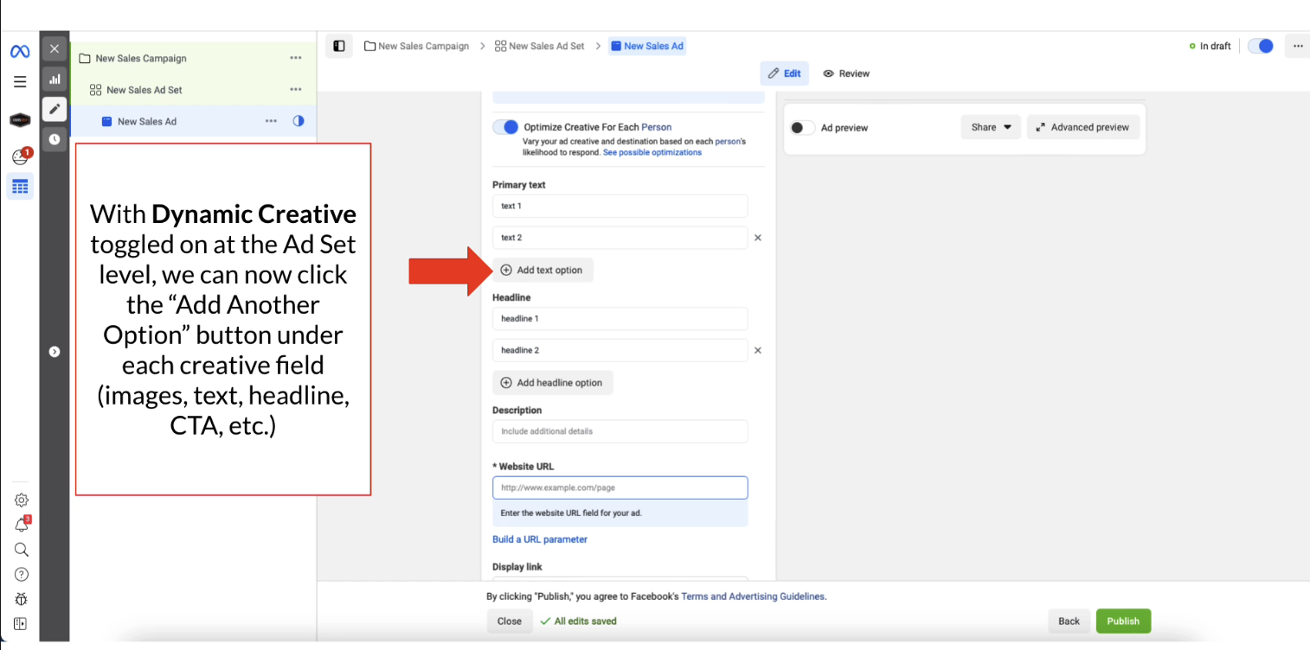

analysis
- Ads Manager > Ads Tab > Breakdown menu > Dynamic Creative Asset
  - select each Dynamic Creative Asset to review results
- one campaign for testing and one for performance
  - test for 3 days
  - review Dynamic Creative Assets via Breakdown menu
  - identify best Custom Audience

Ad Creative

general
- what makes your product special
  - what is your unique selling proposition
- how is your product a SOLUTION to their PROBLEM
  - SELL THE OUTCOME
  - test different ways to convey this with your creatives
- split test
- get people to say “YES” (literally)
  - this is micro transaction

middle of funnel

answer OBJECTIONS that the customer may have about your product
- share why XYZ is worth their time
- use testimonials
- money back guarantee

test scarcity and FOMO creatives
- show a success story

test various ad copy to see which Objection Debunk results in sales
- can be used in TOF
- may include ANSWERS to common objections before they happen
  - 30 day money back guarantee
  - clearly describe what the product does / problem it solves
  - free gift

high priced product (100$ +)
- continue to build trust
- provide value
- nurture relationship with
  - ads narrative / store
  - testimonials
  - why people should care
- hit the “7 Touch Points” of people seeing and learning about brand before they buy

bottom of funnel

user generated content
- video testimonials
- customer reviews
  - create a slideshow or video
- images of customers with product
  - carousel ads

build credibility
- why should they trust you
  - awards won
  - total customers

ads relevant to retarget audience
- Ad to Cart audience
  - remind them that they left something in cart
  - use a 10% off coupon to return and finsihe checking out
  - for these guys exclude the Past Customer Audience

PRO TIP
- don’t always use discounts
- limited time only
- bonus item to add value and incentivize

User Generated Content
- unboxing videos for products
- carousel ads with different customer testimonial video/ text
- written reviews in a 30 second video slidesho with images of product, customer pics and text overlay
- customers wearing or using your product in videos or images

Track Testing
- all data is stored in Facebook Ads Manager
- manually review and pull data to look in a spreadsheet

spreadsheet layout

tabs
- audiences
- age
- gender
- location
- placements
- creative

columns
- identifier
  - interest targeted
- amount spent
- CPM (cost per 1000 views)
- CPC (cost per click)
- CTR (click through rate)
- Conversions
  - leads
  - purchases
- Cost Per Result (CPA)
- Revenue
- Profit

